Ouran Forenz Case 1 Asset List:

EVIDENCE:

Attorney Badge

Autopsy Report: Bog standard manilla folder.

Big Stick: A short thick stick. Weighty enough it could kill, but not so much that it looks like it was carved from a tree. Something you might be able to find laying on the ground. Alternatively, just make it a club within a 100 pixel by 100 pixel box if that is easier.

Picture of Al Protecc: Picture of the victim. Background can be whatever, but he’s holding like a mug in his left hand. LEFT HAND. Al Protecc described below.

Security Footage: Two still images. The first one shows Gilligan Tam and Al Protecc walking away from the camera. The hallway is angled such that they are walking towards the top left corner of the frame. Gilligan is holding his briefcase. Timestamp 9:50 PM. Second image shows Gilligan leaving. Still holding briefcase. Walking towards bottom left corner due to perspective. Timestamp 10:00 PM. The hallway in these two should be identical. I guess just draw a generic hallway, nothing really in it, then use it for both pictures.

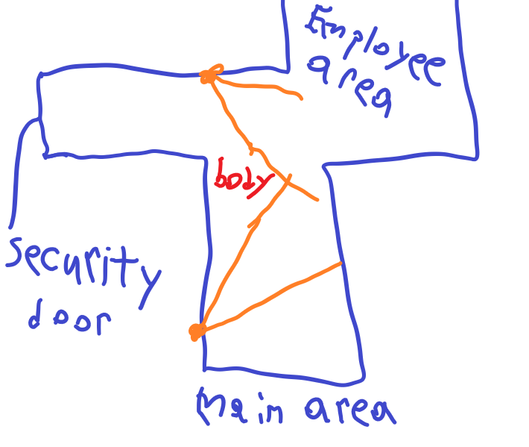Diagram of bank: So really the orange balls are cameras and the lines are where they see. What this needs to get across is that the cameras have a blind spot that only a security guard would know of.

Photo of Body: Al Protecc dead. Pool of blood around head. Blood on tip of right-hand index finger. Death message in blood saying GILL T in big bold letters.

CHARACTERS:

Ouran Poses:

Objection Pointing: You know

Thinking: Whatever you want that looks like thinking (except Apollo’s stupid thinking pose)

Confident: Index and middle fingers on side of glasses kind of pushing them up. Glasses white like light shining on them so you can’t see his eyes.

Shock: Taken aback. Slightly weirdly contorted arms (nothing crazy just like a bend or something…). Pupils gone so just the whites oh his eyes. Shocked expression.

Sheepish or concerned: Elbows on desk hands on cheeks with fingers over the side of glasses. Generally exasperated looking.

Hand slam: Hands slammed on to desk.

Smile: He is posed normally, just smiling…

If you think of any more let me know.

Mel Practiss Poses:

Nervous: General nervous expression. This is his default.

Nervous smile: Similar but smiling. Mel is winning at these points.

Shock: Jaw dropped, eyes bugging out.

Depressed: Hunched over onto the table. Just generally given up.

Judge Judge:

Neutral: Normal expression

Surprised: Shocked a little.

Impatient. Furrowed brow. He’s tired of Ouran’s shit.

Gilligan Tam:

Short stubby guy. Kind of gruff or tough looking. Think gumshoe but looks more like a criminal and is short. Important that he’s short.

Normal talking sprite

Yelling: He’s just speaking very loud. Very passionate about what he’s saying like “I’m innocent” or “That taco stand is amazing”

Sad or depressed:

Enrico:

I have no idea what this dude looks like. Personality is like Luke Atmey but less over the top.

Normal talking: Over confident looking.

Fake sad: He looks sad, but he more looks like he’s faking a little.

Laughing: He’s laughing like big maniacal laugh. Like hands held up evil laugh.

Anger: Not super furious but like annoyed at being accused for a crime he def did not commit (kidding he did)

Breakdown: I know you like the breakdowns so like you can make whatever for the breakdown. I really have no clue.